Part 1
- A piano is pushed across a wooden floor with a force of 2500 N. The piano moves a distance of 3.5 m. Calculate the work done moving the piano.
- Work done is usually measured in joules. An alternative unit for work done is (circle the correct answer).
kg/m³ Nm W N/m2 N/kg
- Why does a bicycle pump get hotter when used to pump up a tyre?
- A box with a weight of 120 N is lifted up 1.8 m onto a shelf. Calculate the work done in lifting the box.
- When a book is lifted 3 m the work done on the book is 1.2 J. Calculate the weight of the book.
- Javier Sotomayor is the current men's record holder with a jump of 2.45 m His mass is 82 kg.
(g = 10N/kg)
- What type of stored energy does he have as he clears the bar?

- Work out how much stored energy Javier Sotomayor has due to his position above the ground.

- As he falls back to the ground, this energy store will be transferred into a new energy store. Name this new energy store.
- When a tennis ball is hit with a racket it gains kinetic energy.

a. What is the formula used to calculate kinetic energy?

b. The tennis ball has a mass of 56 g and hit has a velocity of 48 m/s. Work out the kinetic energy
of the moving ball?
- Describe how the thermal energy applying the brakes on a bike while riding along a road is dissipated.
a. The diagram shows the main energy transfers for an electric kettle. Complete boxes A to D
showing the energy stores involved. Use the size of the arrows to help you.

b. State why the total energy supplied to an electric kettle must always equal the total
Part 2
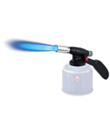
- Give two alternative units of power?

- A blowtorch burns butane gas to heat metal pipes.
a. Describe the energy transfers which occur as it is used.
………….. energy is transferred into
.…………. energy usefully and
………….. energy is wasted.
b. Explain how some of the transferred energy is wasted.
c. The blowtorch transfers 2 kJ of energy in 4 mins. Work out the power of the blowtorch?

- Two cranes are lifting the same load of 120 kg to a height of 15 m.
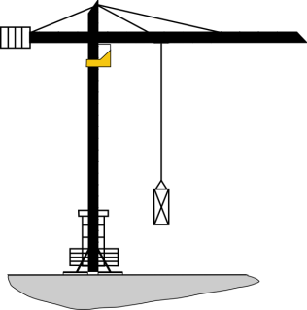
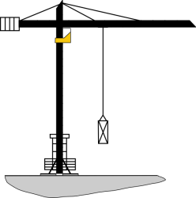
Crane A Crane B

Crane A takes 30 s to lift the load. Crane B lifts the same load in 9 s.

Calculate the difference in power of the two cranes.

- The diagram represents the energy store transfers when a motor is lifting a weight.
- How much electrical energy is transferred to a thermal energy store?
- What is the total amount of dissipated energy?
- Calculate the efficiency the of the useful energy transfer

